|  |
| --- |
| #!/bin/sh  echo "hello world"  exit 0 |

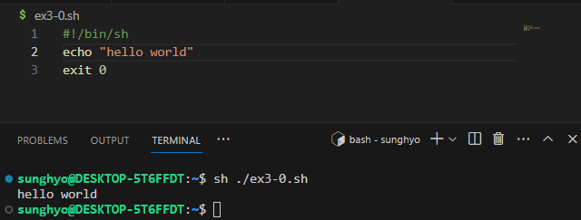

|  |
| --- |
| #!/bin/sh  if [ -n "$1" ]; then  i='1'  while [ $i -le $1 ]  do  echo "hello world"  i=`expr $i + 1`  done  else  while [ 1 ]  do  echo "hello world"  done  fi  exit 0 |

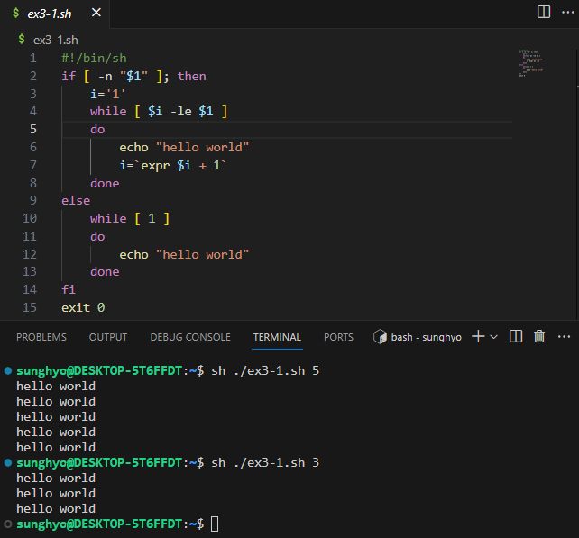

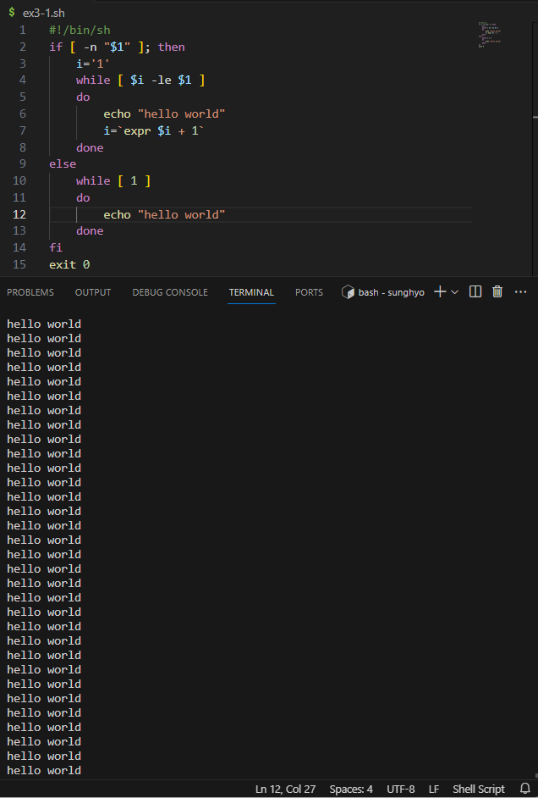

|  |
| --- |
| #!/bin/sh  num=`expr $1 $2 $3`  echo "$num"  exit 0 |

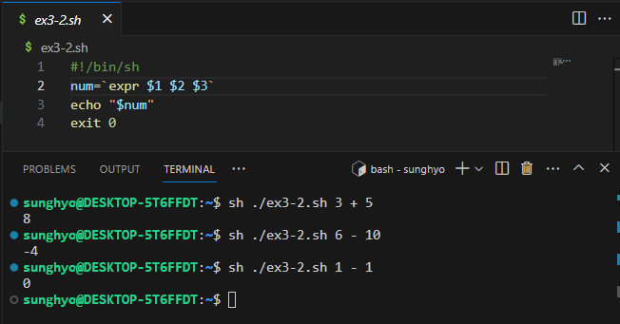

|  |
| --- |
| #!/bin/sh  weight=$1  height=$2  height_squared=$(($height * $height))  bmi=$(($weight * 100000 / $height_squared))  if [ $bmi -lt 185 ]; then  echo "저체중입니다."  elif [ $bmi -lt 230 ]; then  echo "정상입니다."  else  echo "과체중입니다."  fi  exit 0 |

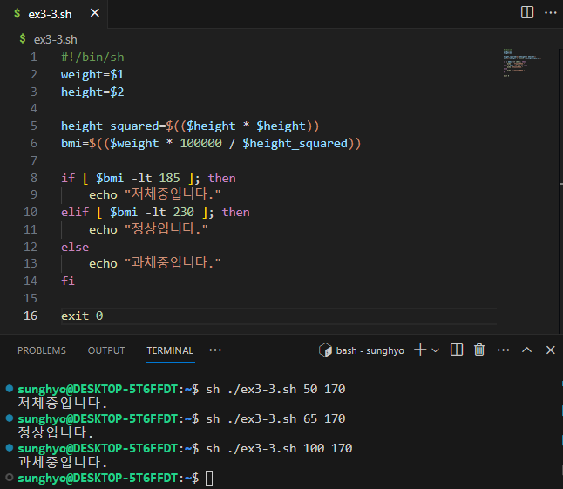

|  |
| --- |
| #!/bin/sh  echo "리눅스가 재밌나요? (yes / no)"  read answer  case $answer in  yes | y | Y | Yes | YES | yyy | yesyesyes)  echo "yes";;  no | n | N | No | NO | nono | nonono)  echo "no";;  *)  echo "yes or no로 입력해 주세요. "  exit 1;;  esac  exit 0 |

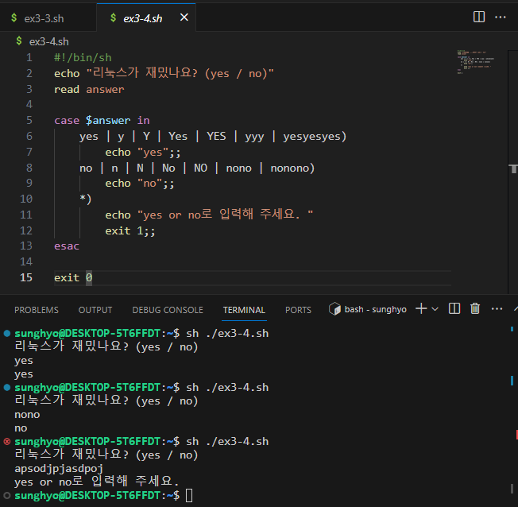

|  |
| --- |
| #!/bin/sh  myfunc() {  echo "함수 안으로 들어왔음"  ls $1  }  echo "프로그램을 시작합니다"  myfunc $1  echo "프로그램을 종료합니다"  exit 0 |

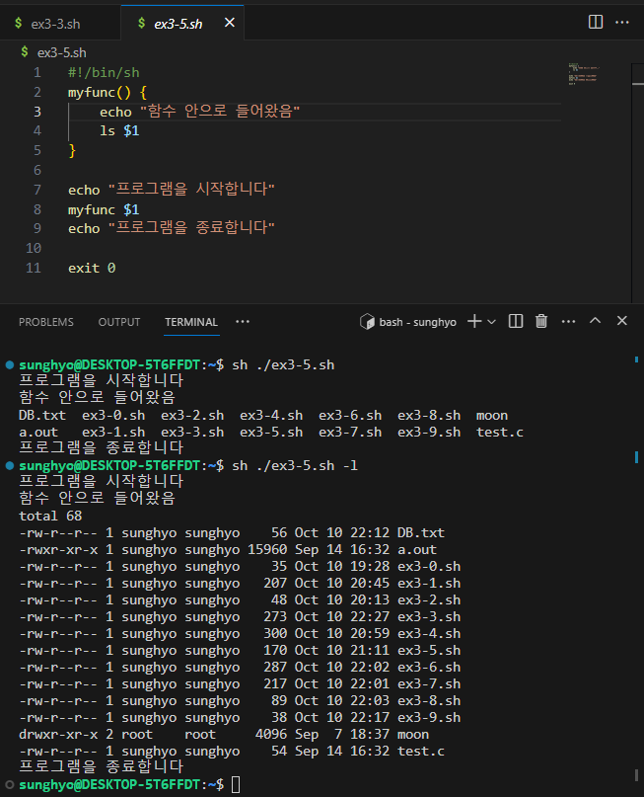

|  |
| --- |
| #!/bin/sh  if [ ! -d "$1" ]; then  mkdir $1  cd $1  i=0  while [ $i -lt 5 ]  do  touch "file$i.txt"  i=$((i + 1))  done  tar cvf $1.tar file0.txt file1.txt file2.txt file3.txt file4.txt  mkdir $1    mv $1.tar $1  cd $1  tar xvf "$1.tar"  fi  exit 0 |

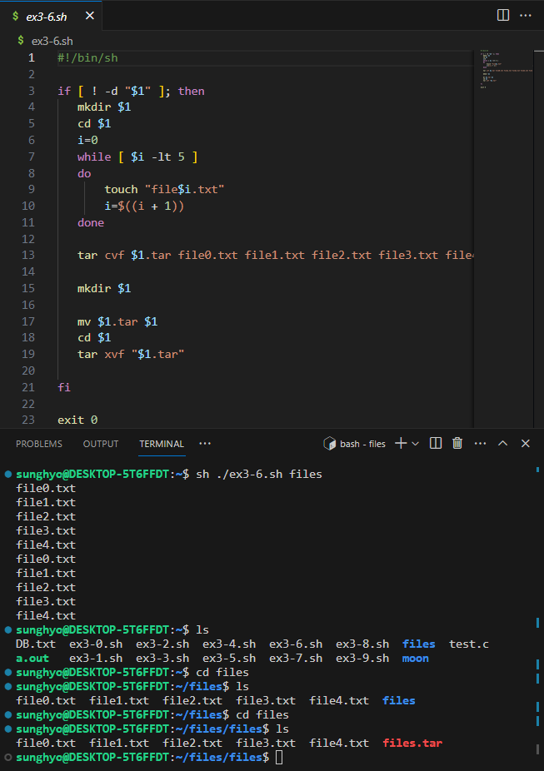

|  |
| --- |
| #!/bin/sh  if [ ! -d "$1" ]; then  mkdir $1  cd $1  i=0  while [ $i -lt 5 ]  do  touch "file$i.txt"  mkdir file$i  ln -s file$i.txt file$i/file$i.txt  i=$((i + 1))  done  fi  exit 0 |

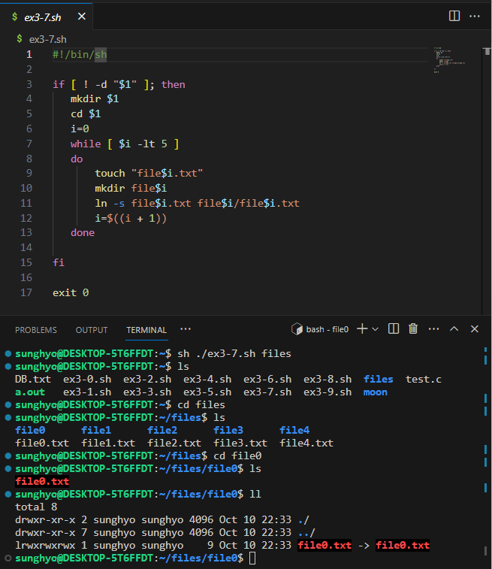

|  |
| --- |
| #!/bin/sh  if [ ! -d "DB.txt" ]; then  touch "DB.txt"  fi  echo "$1,$2" >> DB.txt  exit 0 |

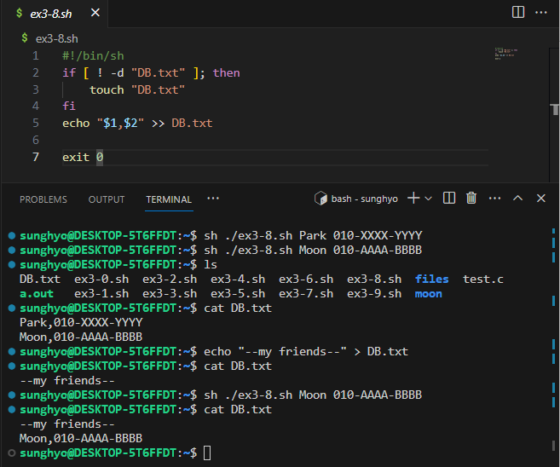

|  |
| --- |
| #!/bin/sh  sed -n "/$1/p" DB.txt  exit 0 |

